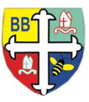Bishop Bridgeman Primary School – We Work, We Play, We Care, We Pray

**Update**This half term the children will experience more structure as we begin our direct sessions with them. This means they will complete phonics, maths and mark making sessions in very small groups or 1:1 with an adult. We will then continue with group sessions on the carpet and sessions within the different provision areas.

**Literacy**

This term we are still helping the children to sit together in small groups, listening to stories and joining in with songs and rhymes. We will be looking at more books such as Goldilocks and the Three Bears and Owl Babies. We will be creating provision areas to suit the stories.

**Mathematics**

We will be helping the children to begin recognising numbers 1 and 2, recognising them in different forms as well e.g the number 2, two dots, 2 on a bus. We are still focusing on counting objects 1:1 (touch and count). We will also be looking at patterns.

**Wider Curriculum**

We will be looking at different faiths and their celebrations this half term. We will also be looking at seasonal changes (science) as well as celebrating the build up to Christmas with our Nativity.

**Notices**

Please ensure that snack money for your child is paid in full at the beginning of each half term. This term is £7.

Please ensure that you are punctual when dropping and collecting your child. Morning Session (8.30am-11.30am) Afternoon Session (12.30pm- 3.20pm).

Please nameyour child’s coat and any other items such as jumpers and cardigans that they may take off during the session. This helps the staff to ensure that all items can be returned.

Children in Nursery need to bring a fresh bottle of water into school each day (please do not send cordial or juice).

If you need to contact the team, we check the email inbox for [nursery@bishop-bridgeman.bolton.sch.uk](mailto:nursery@bishop-bridgeman.bolton.sch.uk) regularly.

Thank you,

Miss Breen, Mrs Cooper, Mrs Munshi & Mrs Virmani

**Home Challenges**

* Share a story with your child each day.
* Join your local library.
* Talk about different shapes around the home or when you are ‘out and about’.
* Sing nursery rhymes together (Rhyme of the week)

EarlyYearsFoundationStageBishopBridgeman

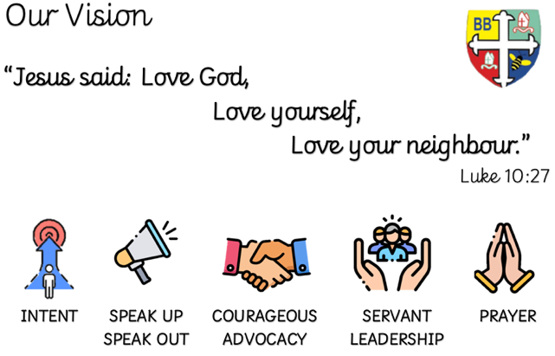



**RE**

Our focus for the half term is looking at Diwali and Christmas celebrations. We will investigate how different faiths celebrate their festivals.

**Physical Development**

All children have access to the outside area including our natural area, which is outside. We will be learning how to keep the learning environment clean, safe and tidy. We will also be exploring different ways to move and how to play games together, sharing and taking turns.

Nursery Termly Newsletter Autumn 2 2023