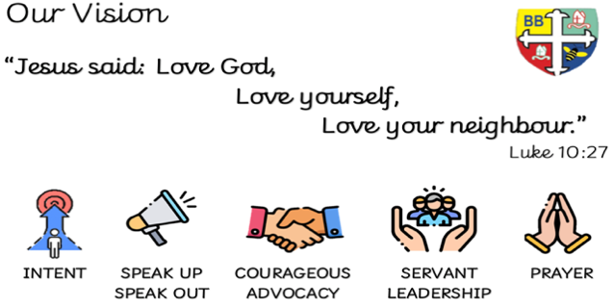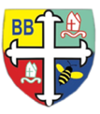Bishop Bridgeman Primary School – We Work, We Play, We Care, We Pray

**PE**

This term in PE our focus will be ‘Dance’ and ‘Competitive Games’. In. Competitive Games, we will show control when dribbling the ball and change speed and direction. In Dance, we will perform a dance in the role of a character and complete movements to the count of 4.

**RE**

This term we will be learning about ‘Places of Worship’ including a Mosque, a Synagogue, Gurdwara and a Temple.

**Homework**

Homework will be now be set on paper every Friday. Homework is due to be handed back in the following Wednesday.

**Computing**

*This term in Computing we are focusing on the topic ‘Art, Design and Music’. We will use software to create simple musical compositions and use our own sounds within our music.*

**Class Routines**

*Children need their PE kits in school on Wednesday and Thursday!*

*Snack money to be paid on a Monday for the half term or £1 each week.*

**Science**

This term we will be learning about Plants. We will identify and name a variety of common wild and garden plants, including deciduous and evergreen. We will also look at describing the basic structure of common flowering plants including trees: trunk, branches, leaves and roots.

**Maths**

This term in Maths we will be focusing on Time and Statistics. We will be telling the time to the hour, half past, quarter past and quarter to. We will also be revisiting the days of the week and Months of the Year. We will also be interpreting and presenting data using tally charts and block diagrams.

**English**

This term in English we will be reading ‘The Bear and the Piano’. We will be working on using subordination in our sentences (because, that, if, when) and expanded noun phrases. We will build up to writing our very own narrative.

**Topic**

This term in Geography we will be learning all about ‘Blackpool’. This half term we will have a particular focus on Art, as part of our Blackpool Topic. We will become Architects and build our very own structure based around Blackpool pier.

@BishopBridgeman

Year 2 Half Termly Newsletter June 2023