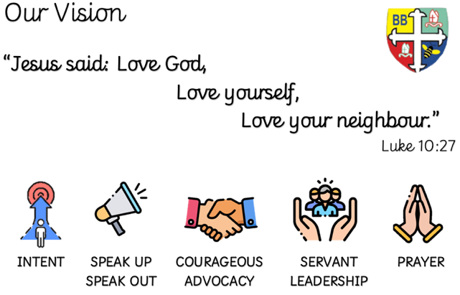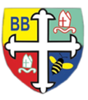Bishop Bridgeman Primary School – We Work, We Play, We Care, We Pray

**Science**

This term we will be learning about animals including humans. We will find out about the different types of skeletons, vertebrates and invertebrates, name some of the bones in our body and also look at the different food groups that keep us healthy.

**PE**

PE is on a Monday and Friday. This term in PE we will be learning about sending and receiving. We will be learning new skills and developing old ones. Please ensure your child has a full PE kit in school at all times.

@BishopBridgeman

**Class Routines**

Please ensure your child has their book bag in school every day. It is really important that your child reads every night, even if only for 10 minutes. Snack money is due every Monday. If you would like your child to have snack please send in £1 each Monday. Thank you for your continued support.

**Homework**

Homework will be set on seesaw every Friday. Please ensure your child is able to log on and complete their tasks each week. Seesaw logins will be given in the next week.

**RE**

This term we will be learning about the sadness and joy of Easter. We will learn about the Easter story and what it means to people of the Christian faith.

**Computing**

This term in Computing we are focusing on the coding. Children will learn how to sequence a code to make a short animation.

**Topic**

This half-term we will be focused on a Design and Technology unit based on our recent History unit of Vikings. We are going to design our own Longboat sail, something that made the Vikings easily recognisable and had a great significance to them.

**Maths**

This term in Maths we will be learning about fractions. We will be recognising unit and non-unit fractions, tenths, fractions on a number line, comparative fractions and also adding and subtracting fractions. We will also be consolidating our 2, 3, 4, 5, 8 and 10s times tables.

**English**

This term in English we will be completing a reciprocal read of Arthur and the Golden Rope, using our imagination to understand the text and write our own narratives.

Year 3 Half Termly Newsletter March 2023