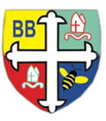Bishop Bridgeman Primary School – We Work, We Play, We Care, We Pray

**Notices:**

* Please read your child’s reading book at home for at least 5 minutes every day.
* Please check your child’s book bag for letters / check Seesaw for messages.
* Thank you for continuing to support us to be nut free. Please continue to be mindful when sending lunches / food from home.
* Snack contributions are due: £5 for the half term.

Dates for your diary:

* Thursday 2nd March – library visit
* Friday 3rd March – World Book Day – dress up as a book character
* Friday 10th March – class photographs
* Friday 17th March – 2pm: Red Nose Day and Mothers’ Day party in school {information to follow}
* Tuesday 28th March – information to follow: street dance performance
* Friday 31st March – 2pm – Easter celebration in class

If you have any questions about anything – please call in or email.

**Physical Activity**

Reception continue to have a dance session in the hall every Tuesday morning with Laura, our dance teacher and with Mr Smith, our PE coach every Wednesday. Please send in a PE kit for your child if you haven’t already. In addition to this, the children have access every day to our outdoor area to develop their gross motor skills.

To celebrate the street dance skills learned, the children will be putting on a performance!

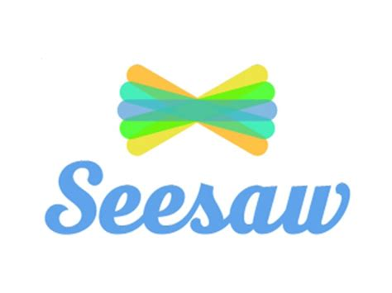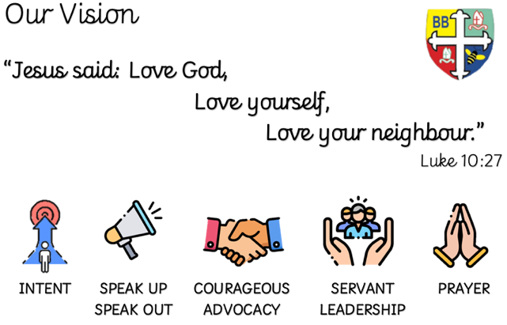

Earlyyears Foundationstage Bishopbridgeman Seesaw

**Phonics**

We assessed the children’s phonic skills before half term and have planned sessions to move the children forward after half term. We will start to teach phase 4 graphemes which will introduce longer words – be prepared to be impressed! Some children will also continue to re-visit phase 2 to develop confidence – as always we will send homework for you to practise at home.

**Mathematics**

In maths we are working our way through the White Rose Maths sessions and will be focussing on building 9 and 10. Some of our children can work beyond but the lessons are planned to deepen understanding ready for the transition to Year 1 – there are lots of ideas online for White Rose maths games at home. Keep an eye out on Seesaw for ideas of activities to carry out at home.

**Literacy**

As we continue our writing journey all children now have a guided writing book which we use weekly to write graphemes, words and captions. We are encouraging the children to remember the non-negotiables of: capital letters, finger spaces and full stops.

**Welcome Back!**

We hope you have had a lovely half term holiday. We have lots going on this half term so pens and diaries at the ready!



Reception Half Termly Newsletter February 2023