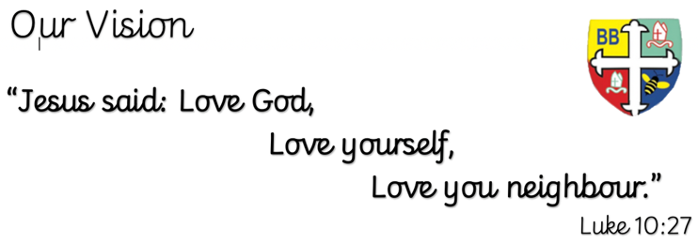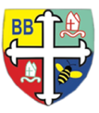Bishop Bridgeman Primary School – We Work, We Play, We Care, We Pray

**Class Routines**

Please ensure your child has their book bag in school every day. It is really important that your child reads every night, even if only for 10 minutes. PE has moved to Tuesdays and Thursdays; Pupils can go home in their PE kits on Thursdays, which need to be washed before the following Tuesday.

**Homework**

Homework will be set on seesaw every Friday. Please ensure your child is able to log on and complete their tasks each week. Please speak to a teacher if you are having login issues.

**RE**

This term we will be learning about Jesus as a Teacher

**Computing**

This term in Computing we are focusing on the topic ‘Spreadsheets – Using formulae to solve mathematical problems and model real life

situations.

**PE**

This term in PE we will be learning about fundamental movements and gymnastics. Please ensure your child has a full PE kit in school at all times. Our PE days are Tuesday and Thursday

**Science**

This half term we will be learning about animals including humans. The topic will have a development focus, where we will be learning about the Human lifecycle from foetus to old age, as well as the gestation periods of a range of animals.

**History**

This half term we will be learning about Ancient Greece which ties in with our Greek Myths topic in English. We will be looking in depth at the Ancient Greek timeline, where we will be learning about the Ancient Greek Religious system, Alexander the Great, the Olympics and Ancient Philosophers.

**Maths**

This half term in Maths we will be learning about Fractions. We will practise finding equivalent fractions, adding and subtracting fractions and converting improper fractions to mixed numbers. We will move on to multiplying fractions as well as revisiting finding a fraction of an amount.

**English**

This half term in English we will be learning about Ancient Greek Myths. We will be reading Theseus and the Minotaur; Pandora’s Box; Perseus and Medusa and the story of Icarus. We’ll be continuing to use year 5 grammar and focussing on writing using non-negotiable features.

@BishopBridgeman

Year 5 Half Termly Newsletter January 2023