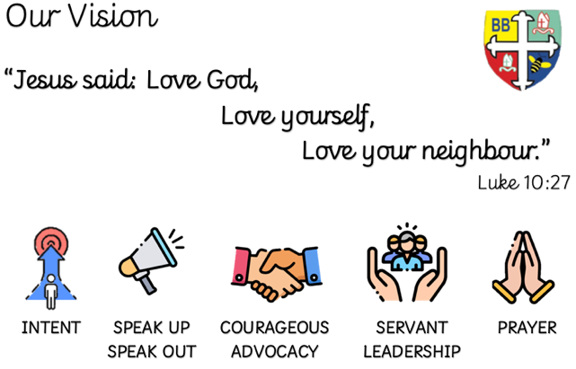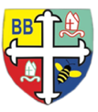Bishop Bridgeman Primary School – We Work, We Play, We Care, We Pray

**Class Routines**

Please ensure your child has their book bag in school every day. It is really important that your child reads every night, even if only for 10 minutes. Snack money (£1) is due every Monday or you can pay in full for the half term. Children need their PE kits in school every Tuesday and Wednesday. Thank you for your continued support.

**Homework -** will be given at the beginning of each half term. The children will be given 6 pieces of homework and can choose at least 2 to complete. The more they complete the more chance they have to win a prize. Spelling will be given weekly and reading books should be read every day.

**RE**

This term we will be learning about ‘The Bible’. We will be discussing why the Bible is a special book and learning lots of facts about the first Bible and where it came from.

**Computing**

*This term we will learning about ‘Online Safety’. This will include learning about how to keep safe online and what personal information should and should not be shared with others.*

**PE**

This term in PE we will be developing our Gymnastic skills including different positions such as pike, straddle, back support and dish. We will also be practising how to perform a handstand and forward roll.

**Science**

This term we’ll be learning about Materials. We’ll be looking at different materials including wood, glass, fabric, metal and discussing the properties of each including which materials are shiny, hard and soft.

**Topic**

This term in Geography we will be learning all about ‘William Hesketh Lever’. We will learn all about his life and put his life events onto our own timeline. We will learn about the influence he had on the Rivington Gardens and make our very own soap, just as William did!

**Maths**

This term in Maths we will be focusing on Place Value. We will be recognise and writing numbers to 100. We will also be using 10s and 1s counters to make numbers to 100 looking at how many 10s and 1s each number has.

**English**

This term in English we’ll be reading the story ‘Meerkat Mail’. We’ll be learning the story through images/actions and will be re-telling the story, asking questions and describing characters using adjectives.

Year 2 Half Termly Newsletter September 2023

@BishopBridgeman