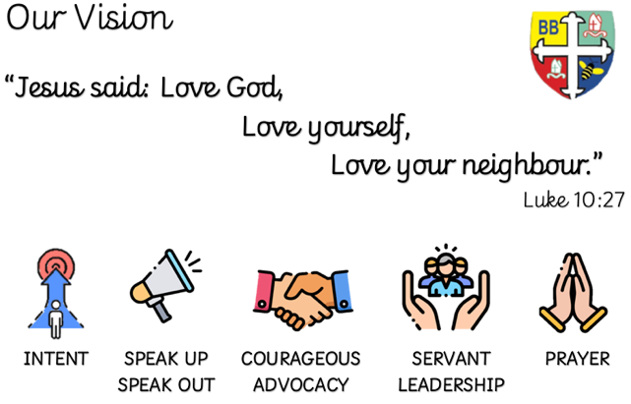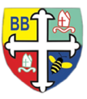Bishop Bridgeman Primary School – We Work, We Play, We Care, We Pray

**Class Routines**

Please ensure your child has their book bag in school every day. PE kit is needed on Monday and Thursday. Thank you for your continued support.

**Homework**

Homework will be daily – that will be reading at least 10 mins each day after school. Please record that you have listened to your child each day in their reading record.

Weekly – Times Tables Rockstars (TTRS), MyMaths and spellings

Half-termly – 6 tasks to be completed (minimum 4). Each task has an approx. timescale so that children can put in the expected effort to the task. Those that complete the 4 or more will be added into a prize draw at the end of each half-term.

**RE**

This half term we will be learning about David, God and the Psalms and Change the World.

**Spanish**

This half term we will be learning about Me Presento (Presenting Myself) with some phonetic work too.

**PSHE**

This half term we will be learning about Being me in my world

**Computing**

This term in Computing we are focusing on the topic ‘Online Safety’. Themes covered include self-image & identity, online relationships and health & well-being. There will be lots of activities and discussions to ensure the children are well equipped to stay safe online.

**PE**

PE is on a Monday and Thursday. This term in PE we will be learning about fundamental movements. We will be learning new skills and developing old ones. Please ensure your child has a full PE kit in school at all times.

**Science**

This half term we will be learning about Living Things and Their Habitats. We will be finding about how animals are grouped, including vertebrates and invertebrates. We will find out about the way that different animals are grouped and how they adapt to their surroundings.

**Topic**

This term in history we will be learning about the Romans. We will find out about some of the important dates, the rise of the empire and those rulers that conquered many lands, including Britain.

We will then move on to a DT unit of structures and this will be linked to the Romans unit. We will be designing and building aqueducts.

**Maths**

This term in Maths we will be learning about number and place value. We will be recognising the place value of each digit in a number, up to and including four-digit numbers. We will be counting in seqences of 6, 7, 25, 50 and a 1000, negative numbers and roman numerals. We will be learning our timestables, including 6, 7, 9, 11 and 12s.

**English**

This term in English we will be completing a reciprocal read of Varjak Paw, a story about a Mesopotamian Blue cat, who knows he is different but must learn The Way like his ancestor to save his family. The children will then produce their own newspaper report linked to his exploits. Towards the end of the half-term, we will become sports managers.

Year 4 Half Termly Newsletter September 2023

@BishopBridgeman