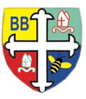Bishop Bridgeman Primary School – We Work, We Play, We Care, We Pray

**Notices:**

* Read your child’s reading book at home for at least 5 minutes every day.
* Please check your child’s book bag for letters / check Seesaw for messages.
* Polite reminder: thank you for your supporting us to be nut free. Please continue to be mindful when sending lunches / food from home.

**Physical Activity**

Reception continue to have a dance session in the hall every Tuesday morning with Laura, our dance teacher and with Mrs Smith, our PE coach every Wednesday. Please send in a PE kit for your child.

In addition to this the children have access every day to our outdoor area to develop their gross motor skills.



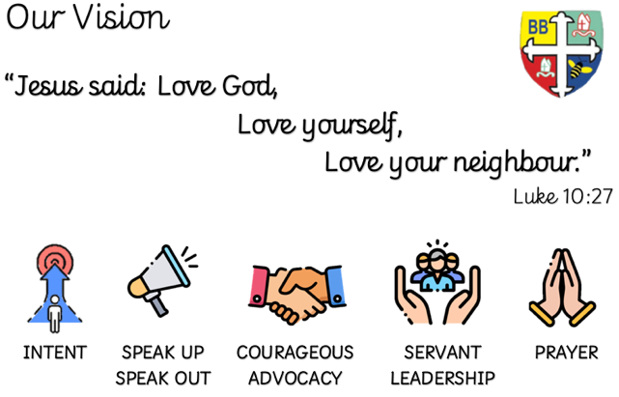

Earlyyears Foundationstage Bishopbridgeman Seesaw

**Phonics**

We assessed the children’s phonic skills before Christmas and have started to teach sessions to ensure all children stay on track. Please see updates on Seesaw for the home challenges that match the phonics your child is being taught – we are teaching phase 3.

**Assessment**

Seesaw is our communication tool. We would be grateful if all Reception parents who are yet to sign up would call in to see the teachers with an email address and we can add you. You will then be able to keep up to date with the exciting activities we plan and never miss another message!

**Literacy**

As we continue our writing journey we will encourage the children are now using the phonics we have taught to write words and simple sentences. We discourage the children from copying or tracing letters, and encourage the formation of letters independently. If you’re not sure how to encourage your child at home, please get in touch.

Please spend time each day reading story books; and you could also make up your own! Reading books continue to match the phonics we are teaching, 5 minutes each day will make such a difference.

**Welcome Back!**

We hope you have had a rested Christmas holiday. Keeping ourselves safe continues to be a priority so please keep an eye out for any updates on the school website, Seesaw and our social media. If there is anything you are not sure of please do ask.

**Mathematics**

In maths we are working our way through the White Rose Maths sessions and will be focussing on building 6,7 and 8. Keep an eye out on Seesaw for ideas of activities to carry out at home.

Reception Half Termly Newsletter January 2023