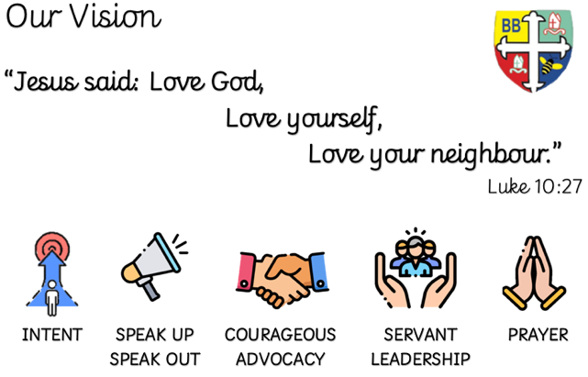Bishop Bridgeman Primary School – We Work, We Play, We Care, We Pray

**Science**

This term we will be learning about Animals including Humans. We will be ordering the life cycle of a human and discuss what happens at each stage of the cycle. We will discuss the five food groups and name examples of different foods in each group.

**Topic**

This term in Geography we will be learning all about ‘Kenya’. We will locate Kenya on a world map, name the countries that border Kenya and find out what continent Kenya is in. We will learn about different physical and human features of Kenya and discuss how the weather in Kenya and United Kingdom differs.

**Maths**

This term in Maths we will be focusing on Measurement. We will be estimating and measuring length/height, mass and capacity. We will compare and order lengths, mass, volume/capacity and record results using <,> and =.

**English**

This term in English we will be learning all about the Great Fire of London. We will create our own non-fiction texts that will include lots of detailed information about ‘Where’ and ‘How’ the Great fire started.

@BishopBridgeman

**Class Routines**

Please ensure your child has their book bag in school every day. It is really important that your child reads every night, even if only for 10 minutes. Snack money is due every Monday. If you would like your child to have snack please send in £1 each Monday. Thank you for your continued support.

**Homework**

Homework will be set on seesaw every Friday. Please ensure your child is able to log on and complete their tasks each week.

**RE**

This term we will be learning about ‘Jesus, a friend to everyone’. We will learn all about Jesus and his 12 disciples and how Jesus performed a miracle.

**Computing**

*This term in Computing we are focusing on the topic ‘Spreadsheets’. We will be learning how to enter data into a spreadsheet, creating graphs and tables.*

**PE**

This term in PE we will be learning about how to ‘attack and defend’ in a variety of different sports.

Please ensure your child has a full PE kit in school at all times – Wednesday & Thursday .

Year 2 Half Termly Newsletter March 2023