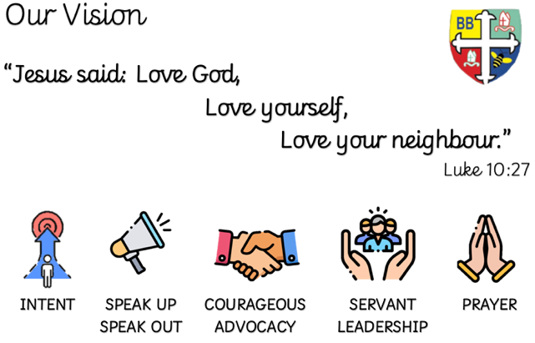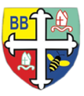Bishop Bridgeman Primary School – We Work, We Play, We Care, We Pray

**English**

This term in English we will be reading the book ‘The Giant’s Necklace’ by Michael Morpurgo. During this unit, we will be practising our reading skills, focusing on inferring meaning from details stated and implied. We will also be analysing the features of and writing our own diaries and newspaper reports.

@BishopBridgeman

**Class Routines**

Please ensure your child has their book bag and P.E kit in school every day. It is really important that your child reads every night, even if only for 10 minutes. Dinner money should be handed in on a Monday in a named envelope. Thank you for your continued support.

**Homework**

Homework will be set on seesaw every Friday. Please ensure your child is able to log on and complete their tasks each week.

**RE**

This term we will be learning about how and why Christians read the bible.

**Computing**

This term in Computing we are focusing on the topic ‘Online Safety’. Themes covered include self-image & identity, online relationships and health & well-being. There will be lots of activities and discussions to ensure the children are well equipped to stay safe online.

**PE**

This term in PE we will be learning about fundamental movements. Please ensure your child has a full PE kit in school at all times.

**Science**

This term we will be learning about forces. We will be learning about gravity and the effects of air resistance, water resistance and friction on moving objects. We will also be investigating how mechanisms have an effect on force.

**Topic**

This term in geography we will be learning about Italy. We will find out all about its location in Europe using atlases and globes. We will also be learning its key human and physical geography and comparing this with our own.

**Maths**

This term in maths we will be learning about number and place value. We will be looking at the value of numbers to 1,000,000, comparing and ordering numbers and recognising negative numbers in the context of temperature.

Year 5 Half Termly Newsletter September 2022