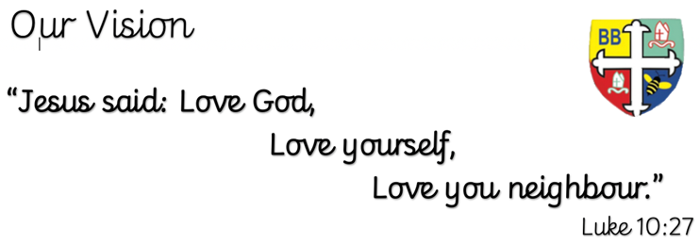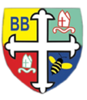Bishop Bridgeman Primary School – We Work, We Play, We Care, We Pray

**English**

This term in English we will be completing a reciprocal reading sequence of learning around the short text ‘The mysteries of Harris Burdick’. We will be focusing on a variety of grammatical features and creating our own diary account.

@BishopBridgeman

**Class Routines**

Please ensure your child has their book bag in school every day. It is really important that your child reads every night, even if only for 10 minutes. Thank you for your continued support. P.E is on Tuesdays and Thursdays, please ensure kit is in school.

**Homework**

Homework will be set on seesaw every Friday. Please ensure your child is able to log on and complete their tasks each week.

**RE**

This term we will be learning about the Eucharist.

**Computing**

This term in Computing we are focusing on the topic ‘Online Safety’. Themes covered include self-image & identity, online relationships and health & well-being. There will be lots of activities and discussions to ensure the children are well equipped to stay safe online.

**PE**

This term in PE we will be learning about attacking and defending through a range of different sporting activities. Please ensure your child has a full PE kit in school at all times.

**Science**

This term we will be learning about light. We will be looking at reflection, refraction, shadows and Isaac Newton’s observations about the colour spectrum.

**Topic**

This term in Geography we will be learning about The Grand Canyon. We will find out all about this area of the world and how it was created. We will be diving deeper into both physical and human aspects of Geography including erosion, climate zones and cultural elements.

**Maths**

This term in Maths we will be learning about percentages, ratio and proportion, algebra. We will be using formal written methods for addition, subtraction, multiplication and division.

Year 6 Half Termly Newsletter January 2023