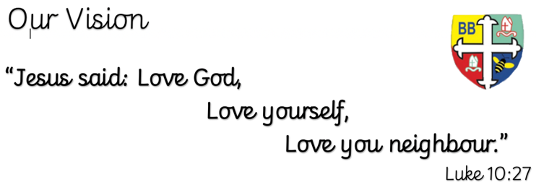Bishop Bridgeman Primary School – We Work, We Play, We Care, We Pray

**English**

This term in English we will be completing a reciprocal reading sequence of learning around the short text ‘Kensuke’s Kingdom’. We will be focusing on a variety of grammatical features and creating our survival guides and short narratives.

@BishopBridgeman

**Class Routines**

Please ensure your child has their book bag in school every day. It is really important that your child reads every night, even if only for 10 minutes. Thank you for your continued support. P.E is on Tuesdays and Thursdays, please ensure kit is in school.

**Homework**

Homework will be set on seesaw every Friday. Please ensure your child is able to log on and complete their tasks each week.

**RE**

This term we will be learning about the Passover, Exodus, Who Jesus was and Easter.

**Computing**

This term in Computing we are focusing on the topic ‘Online Safety’. Themes covered include self-image & identity, online relationships and health & well-being. There will be lots of activities and discussions to ensure the children are well equipped to stay safe online.

**PE**

This term in PE we will be learning about attacking and defending through a range of different sporting activities. Please ensure your child has a full PE kit in school at all times.

**Science**

This term we will be learning about animals including humans. We will be looking at the human body including the circulatory system, how the heart works and how healthy/unhealthy lifestyles affect our body.

**Topic**

This term in History we will be learning about World War II. We will find out all about this era of history, including key dates, what the events were and how/why it occurred. Within this we will also complete an Art unit in which we will be focusing on digital media by creating our own propaganda posters linked to WWII.

**Maths**

This term in Maths we will be focusing on geometry. Within this we will be learning about shapes, angle types, missing angles and using protractors. We will be using formal written methods for addition, subtraction, multiplication and division throughout.

Year 6 Half Termly Newsletter March 2023