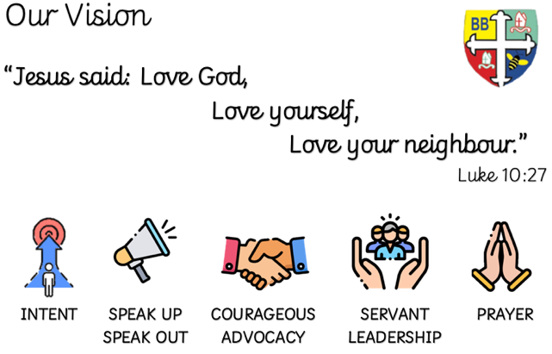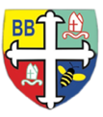Bishop Bridgeman Primary School – We Work, We Play, We Care, We Pray

**Class Routines**

Please ensure your child has their book bag in school every day. PE kit is needed on Monday and Thursday. Thank you for your continued support.

**Homework**

Homework will be daily – that will be reading at least 10 mins each day after school. Please record that you have listened to your child each day in their reading record.

Weekly – Times Tables Rockstars (TTRS), MyMaths and spellings

Half-termly – 6 tasks to be completed (minimum 4). Each task has an approx. timescale so that children can put in the expected effort to the task. Those that complete the 4 or more will be added into a prize draw at the end of each half-term.

**RE**

This half term we will be learning about David, God and the Psalms and Change the World.

**Spanish**

This half term we will be learning about Me Presento (Presenting Myself) with some phonetic work too.

**PSHE**

This half term we will be learning about Being me in my world

**Computing**

This term in Computing we are focusing on the topic ‘Online Safety’. Themes covered include self-image & identity, online relationships and health & well-being. There will be lots of activities and discussions to ensure the children are well equipped to stay safe online.

**PE**

PE is on a Monday and Thursday. This term in PE we will be learning about fundamental movements. We will be learning new skills and developing old ones. Please ensure your child has a full PE kit in school at all times.

**Science**

This half term we will be learning about Electricity, reminding ourselves of circuit symbols and how they work. Exploring the different uses for electricity in our homes

**Topic**

We will continue our DT unit of structures and this will be linked to the Romans unit. We will be designing and building aqueducts.

Then it will be Geography, and we will be learning about the British Isles

**Maths**

This term in Maths we will be learning about number and place value as well as addition, subtraction, multiplication and division. We will be learning our timestables, including 6, 7, 9, 11 and 12s.

**English -**This term in English we will be completing a Read, Write Perform unit based on sports managers. We will be delivering a speech that aims to inspire and encourage our team to glory. We will look at example texts, the language, the effect that the phrases aim to have and hopefully produce some of our own inspiring speeches. We will also look at The Big Book of the UK and see how information can be presented.

Year 4 Half Termly Newsletter November 2023

@BishopBridgeman