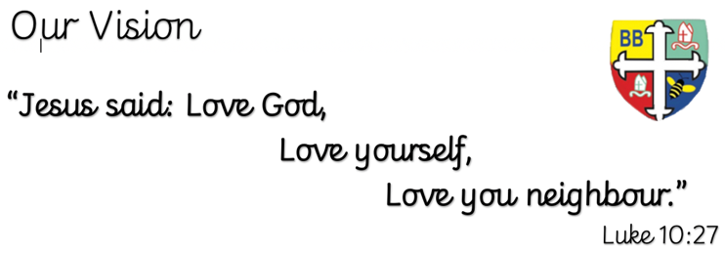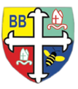Bishop Bridgeman Primary School – We Work, We Play, We Care, We Pray

**English**

This term in English we will be completing a reciprocal reading sequence of learning around the short text ‘The Three Brothers’. We will be focusing on a variety of grammatical features and creating our own short narrative.

@BishopBridgeman

**Class Routines**

Please ensure your child has their book bag in school every day. It is really important that your child reads every night, even if only for 10 minutes. Thank you for your continued support. P.E is on Tuesdays and Fridays, please ensure kit is in school.

**Homework**

Homework will be set half termly, please check the books for the activities and amount required to be done.

**RE**

This term we will be learning about Hinduism, the question ‘Why do Hindu’s try to be good?’ will be our overarching focus.

**Computing**

This term in Computing we are focusing on the topic ‘Computer science’. There will be lots of activities and discussions to ensure the children are well equipped to stay safe online.

**PE**

This term in PE we will be learning about attacking and defending through a range of different sporting activities. Please ensure your child has a full PE kit in school at all times.

**Science**

This term we will be learning about light. We will be looking at reflection, refraction, shadows and Isaac Newton’s observations about the colour spectrum.

**Topic**

This term in Geography we will be learning about The Grand Canyon. We will find out all about this area of the world and how it was created. We will be diving deeper into both physical and human aspects of Geography including erosion, climate zones and cultural elements.

**Maths**

This term in Maths we will be learning about percentages, ratio and proportion, algebra. We will be using formal written methods for addition, subtraction, multiplication and division.

Year 6 Half Termly Newsletter January 2023