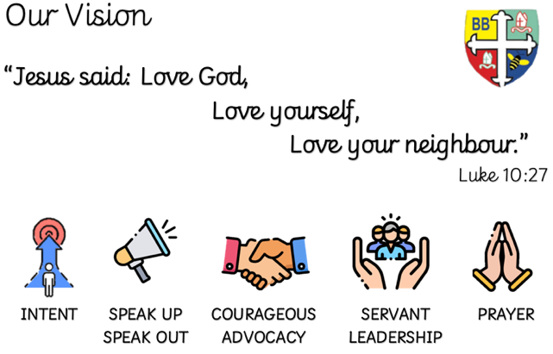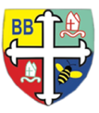Bishop Bridgeman Primary School – We Work, We Play, We Care, We Pray

**Science**

This term we will be learning about plants – the different parts, what plants need to survive and the pollination process.

**PE**

PE is on a Monday and Thursday. This term in PE we will be learning about striking and fielding on Mondays and Gymnastics on Thursdays. Please ensure your child has a full PE kit in school at all times.

@BishopBridgeman

**Class Routines**

Please ensure your child has their book bag in school every day. It is really important that your child reads every night, even if only for 10 minutes. Snack money is due every Monday. If you would like your child to have snack please send in £1 each Monday. Thank you for your continued support.

**Homework**

Homework will be set every Friday and be expected to be returned the following Wednesday

**RE**

This term we will be learning about what it means to be called by God and why Christians sing in worship

**Computing**

This term in Computing we are focusing on simulations and emails.

**Topic**

This half-term we will be focused on a history unit on Tudors. We will also be doing a Design Technology unit based on our recent geography unit on the Lake District, creating a water wheel. As well as this we will be completing an art unit linked with Tudors based on portraits

**Maths**

This term in Maths we will be learning about statistics and also consolidating what we have learnt through the year. In statistics we will interpret and present data using a range of charts and graphs. We will also be solving one and two-step problems. As the year draws to an end, we will be consolidating what we have learnt through the year.

**English**

This term in English we will be completing a Read, Write, Perform unit, based on a villainous speech from Scar. We will then write our own villainous speech in a similar style.

Year 3 Half Termly Newsletter Summer 2023