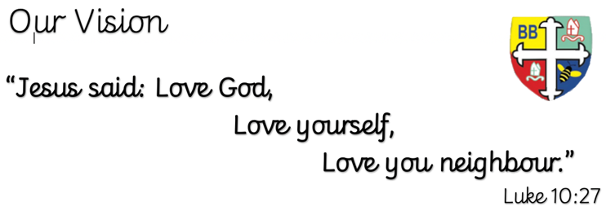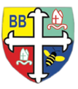Bishop Bridgeman Primary School – We Work, We Play, We Care, We Pray

**Class Routines**

Please ensure your child has their book bag in school every day. It is really important that your child reads every night, even if only for 10 minutes. Thank you for your continued support. P.E is on Tuesdays and Fridays, please ensure kit is in school.

@BishopBridgeman

**RE**

This term we will be learning about pilgrimage.

**Computing**

This term in Computing we are focusing on the topic ‘Online Safety’. Themes covered include self-image & identity, online relationships and health & well-being. There will be lots of activities and discussions to ensure the children are well equipped to stay safe online.

**PE**

This term in PE we will be learning about fundamental movements and gymnastics. Please ensure your child has a full PE kit in school at all times.

**Science**

This term we will be learning about electricity. We will identify the symbols used in circuits and complete a range of practical activities including designing and making our own flood warning device.

**Topic**

This term in Design Technology we will be learning about the mechanisms. We will designing our own automaton products with a focus on CAM mechanisms.

**Maths**

This term in Maths we will be learning about the four operations. We will be looking at negative numbers, rounding and the four operations. We will be using formal written methods for addition, subtraction, multiplication and division.

**English**

This term in English we will be completing a reciprocal reading sequence of learning around the text ‘This is the place. We will be focusing on a variety of grammatical features and creating our own narrative poems.

Year 6 Half Termly Newsletter November 2023