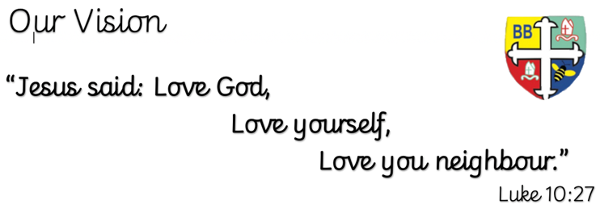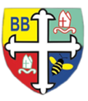Bishop Bridgeman Primary School – We Work, We Play, We Care, We Pray

@BishopBridgeman

**Class Routines**

Please ensure your child has their book bag in school every day. It is really important that your child reads every night, even if only for 10 minutes. Thank you for your continued support. P.E is on Tuesdays and Thursdays, please ensure kit is in school.

**Homework**

Homework will be set on seesaw every Friday. Please ensure your child is able to log on and complete their tasks each week.

**RE**

This term we will be learning about life as a journey.

**Computing**

This term in Computing we are focusing on the topic ‘Online Safety’. Themes covered include self-image & identity, online relationships and health & well-being. There will be lots of activities and discussions to ensure the children are well equipped to stay safe online.

**PE**

This term in PE we will be learning about fundamental movements and gymnastics. Please ensure your child has a full PE kit in school at all times.

**Science**

This term we will be learning about living things and their habitats. We will identify various animal classes as well as learning how to use classification grids.

**Topic**

This term in history we will be learning about the Mayans. We will find out all about this civilisation and the lasting impact it has had on the world. We will be diving deeper into the rise and fall of the Mayans; their culture and what links they have with previous topics we have studied.

**Maths**

This term in Maths we will be learning about number, place value and calculation. We will be looking at negative numbers, rounding and the four operations. We will be using formal written methods for addition, subtraction, multiplication and division.

**English**

This term in English we will be completing a reciprocal reading sequence of learning around the short text ‘The Three Brothers’. We will be focusing on a variety of grammatical features and creating our own narrative.

Year 6 Half Termly Newsletter September 2022