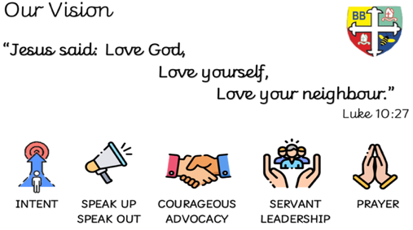Bishop Bridgeman Primary School – We Work, We Play, We Care, We Pray



**Home Challenges**

* Share a story with your child each day.
* Join your local library.
* Talk about different shapes around the home or when you are ‘out and about’.
* Sing nursery rhymes together

EarlyYearsFoundationStageBishopBridgeman



**Notices**

Please ensure that snack money for your child is paid in full at the beginning of each half term. This term is £7.

Please ensure that you are punctual when dropping and collecting your child. Morning Session (8.30-11.25) Afternoon Session (12.30- 3.25).

Please nameyour child’s coat and any other items such as jumpers and cardigans that they may take off during the session. This helps the staff to ensure that all items can be returned.

Children in Nursery need to bring a fresh bottle of water into school each day (please do not send cordial or juice).

**RE**

Our focus for the half term is friendship, we will be discussing what makes a good friend and who are friends are.

**Physical Development**

All children have access to the outside area including our Natural area. We will be learning how to keep the learning environment clean, safe and tidy. We will also be exploring different ways to move and how to play games together, sharing and taking turns.

**Wider Curriculum**

This first term we are focussing on settling all of our new starters into the nursery routines. We will be talking about ourselves and our families, thinking about British Values and celebrating different faiths.

**Mathematics**

We will be helping the children to begin recognising numbers up to 10 and to count objects 1:1 (touch and count). We will also be looking at different shapes around us and talking about them.

**Literacy**

This term we are encouraging the new children to begin recognising their own names – to help with this we have made each child a name card. We are sure that our older children will remember and help the new starters with this. We will also be helping the children to sit together in small groups, listening to stories and joining in with songs and rhymes.

**Welcome** A big welcome to all our children – we are all settling well and enjoying our first term in nursery. We are making lots of new friends and learning to play together.

Nursery Termly Newsletter Autumn 1 2022