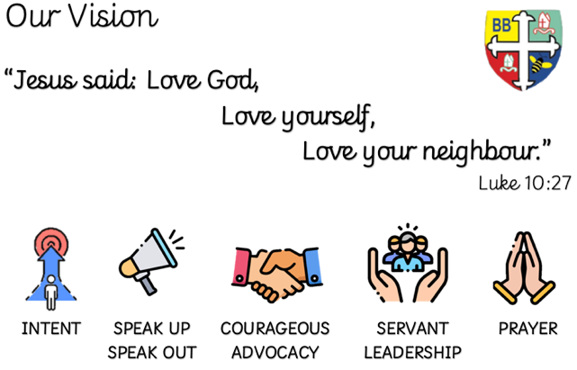Bishop Bridgeman Primary School – We Work, We Play, We Care, We Pray

**Science**

This half term we will be learning about Animals including Humans. We will look at the digestive system and learn about the functions of the different parts. We will learn about the different types of teeth humans have and then identify similarities and differences between carnivores, herbivores and omnivores. We will finish the unit looking at food chains.

**Geography and Art**

In geography we will be learning about the British Isles, finding out about human and physical features of the four countries that make up the UK.

In art we will be learning about using pictures, drawings and sketches to tell a story.

Year 4 Half Termly Newsletter - Spring 1 2024

**English**

This term in English we will be completing a reciprocal read of The Firework-Makers Daughter. Whilst reading the text we will infer the characters feelings, discuss the choice of words and phrases used by Philip Pullman. We will use this text to create a biographical piece based on characters within the story.

**Class Routines**

Please ensure your child has their book bag in school every day. PE kit is needed on Monday and Thursday. Thank you for your continued support.

**Homework**

Homework will be daily – that will be reading at least 10 mins each day after school. Please record that you have listened to your child each day in their reading record.

Weekly – Times Tables Rockstars (TTRS), MyMaths and spellings

Half-termly – 6 tasks to be completed (minimum 4). Each task has an approx. timescale so that children can put in the expected effort to the task. Those that complete the 4 or more will be added into a prize draw at the end of each half-term.

**RE**

This half term we will be learning about What it means to be a Hindu in Britain today

**Spanish**

This half term we will be learning about Mi Familia (My Family) with some phonetic work too.

**PSHE**

This half term we will be learning about Dreams and Goals

**Computing**

This term in Computing we will be learning about spreadsheets, creating documents containing information and using formulas to populate the documents.

**PE**

PE is on a Monday and Thursday. This term in PE we will be learning about Attack and Defend and Gymnastics. We will be learning new skills and developing old ones. Please ensure your child has a full PE kit in school at all times.

**Maths**

This term we will be learning multiplication and division, consolidating multiplying and dividing by 10, 100 and 1000, multiplying two- and three-digit numbers by a single digit and using the ‘bus stop’ method for dividing two-digit numbers by single digits. We will look at Length and Perimeter and Fractions towards the end of the half-term.

@BishopBridgeman